DATA SCIENCE LABORATORY
PRACTICAL RECORD
Python Programs • Expected Outputs • Visualizations • Results
Name: Nilavazhagan Register No.: 250701483
Class / Section: CSE K

Experiment Index
- 1.a — Trend of Data Science Job Postings
- 1.b — Distribution of Data Science Roles
- 1.c — Structured, Semi-structured and Unstructured Data
- 1.d — Encrypt and Decrypt Sensitive Data using Fernet
- 2 — CSV Data Analysis, Preprocessing and Visualization
- 3.a — Data Visualization using Line Plot
- 3.b — Data Visualization using Bar Chart
- 3.c — Data Visualization using Pie Chart
- 4 — Count Word Frequency in a Body of Text
- 5 — Data Collection and Initial Exploration
- 6 — Time Series Analysis of Website Traffic
- 7 — Random Sampling and Sampling Distribution
- 8 — Conduct Z-Test using Python
- 9 — Matplotlib Library and its Uses
- 10 — Array Functions in Data Science (NumPy)
- 11 — Pandas Library in Data Science
- 12 — Detect Outliers in a Dataset using IQR
- 13 — Handle Missing Values and Inappropriate Data
- 14 — Feature Scaling
- 15 — Data Preprocessing in Data Science
- 16 — EDA: Quantitative and Qualitative Analysis
- 17 — Linear Regression
- 18 — K-Nearest Neighbors (KNN) Algorithm
- 19 — Logistic Regression
- 20 — K-Means Clustering

1.a — Trend of Data Science Job Postings

Aim
To perform the experiment using Python and interpret the generated output.

Program / Input Code
import pandas as pd
import matplotlib.pyplot as plt

data = {
"Year": [2015, 2016, 2017, 2018, 2019, 2020, 2021, 2022, 2023, 2024],
"Job_Postings": [120, 150, 190, 250, 330, 420, 600, 760, 900, 1100]
}
df = pd.DataFrame(data)
print(df)
print("\nPercentage growth from 2015 to 2024:",
round((df.Job_Postings.iloc[-1] - df.Job_Postings.iloc[0]) /
df.Job_Postings.iloc[0] * 100, 2), "%")

plt.plot(df.Year, df.Job_Postings, marker="o")
plt.title("Data Science Job Postings (2015–2024)")
plt.xlabel("Year"); plt.ylabel("Number of postings")
plt.grid(True); plt.tight_layout(); plt.show()

Expected Output
Year Job_Postings
2015 120
2016 150
2017 190
2018 250
2019 330
2020 420
2021 600
2022 760
2023 900
2024 1100

Percentage growth from 2015 to 2024: 816.67 %

Visualization
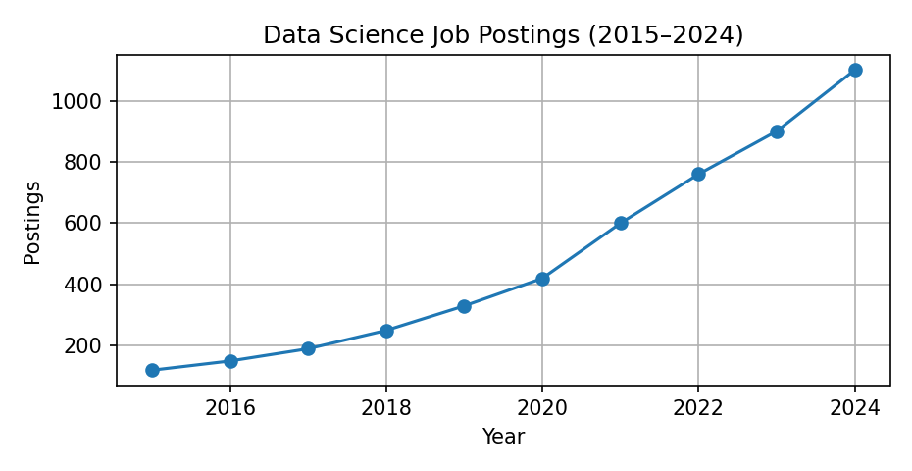

Result
Line graph shows a strong upward trend in data science job postings over the decade.

1.b — Distribution of Data Science Roles

Aim
To perform the experiment using Python and interpret the generated output.

Program / Input Code
import pandas as pd
import matplotlib.pyplot as plt

df = pd.DataFrame({
"Role": ["Data Analyst", "Data Engineer", "Data Scientist",
"ML Engineer", "BI Analyst"],
"Count": [35, 25, 30, 18, 12]
})
print(df)
print("\nMost common role:", df.loc[df.Count.idxmax(), "Role"])
plt.bar(df.Role, df.Count)
plt.title("Distribution of Data Science Roles")
plt.xlabel("Role"); plt.ylabel("Number of job postings")
plt.xticks(rotation=25); plt.tight_layout(); plt.show()

Expected Output
Role Count
0 Data Analyst 35
1 Data Engineer 25
2 Data Scientist 30
3 ML Engineer 18
4 BI Analyst 12

Most common role: Data Analyst

Visualization
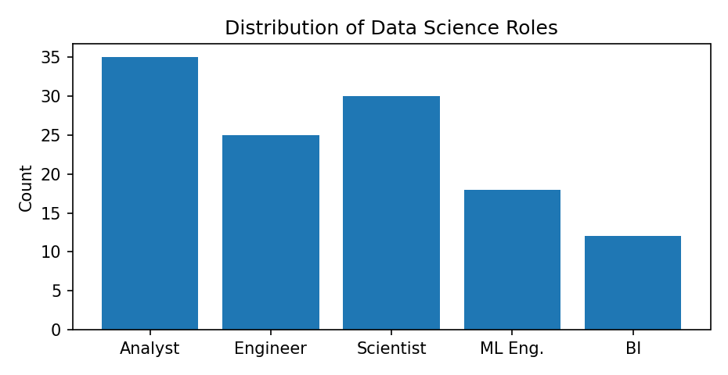

Result
Data Analyst is the most frequent role in this sample dataset.

1.c — Structured, Semi-structured and Unstructured Data

Aim
To perform the experiment using Python and interpret the generated output.

Program / Input Code
import pandas as pd
import json

# Structured: rows and columns
structured = pd.DataFrame({
"ID": [1, 2, 3], "Name": ["Asha", "Bala", "Charan"],
"Mark": [85, 78, 92]
})
print("STRUCTURED DATA")
print(structured)

# Semi-structured: JSON key-value records
semi_structured = [
{"id": 1, "name": "Asha", "skills": ["Python", "SQL"]},
{"id": 2, "name": "Bala", "skills": ["Java"]}
]
print("\nSEMI-STRUCTURED DATA")
print(json.dumps(semi_structured, indent=2))

# Unstructured: free text (no fixed tabular schema)
unstructured = ["Python is easy to learn.", "Data science uses statistics."]
print("\nUNSTRUCTURED DATA")
for sentence in unstructured:
print("-", sentence)

Expected Output
STRUCTURED DATA
ID Name Mark
0 1 Asha 85
1 2 Bala 78
2 3 Charan 92

SEMI-STRUCTURED DATA
[
{"id": 1, "name": "Asha", "skills": ["Python", "SQL"]},
{"id": 2, "name": "Bala", "skills": ["Java"]}
]

UNSTRUCTURED DATA
- Python is easy to learn.
- Data science uses statistics.

Result
Tabular records are structured, JSON records are semi-structured, and free text is unstructured data.

1.d — Encrypt and Decrypt Sensitive Data using Fernet

Aim
To perform the experiment using Python and interpret the generated output.

Program / Input Code
# Install once: pip install cryptography
from cryptography.fernet import Fernet

key = Fernet.generate_key() # Generate a secret key
cipher = Fernet(key)

message = b"Confidential student information"
encrypted = cipher.encrypt(message)
decrypted = cipher.decrypt(encrypted)

print("Original message:", message.decode())
print("Encrypted message:", encrypted.decode())
print("Decrypted message:", decrypted.decode())

Expected Output
Original message: Confidential student information
Encrypted message: gAAAAA... (a new encrypted token is generated each run)
Decrypted message: Confidential student information

Result
Fernet successfully encrypts the original message and decrypts it back using the same secret key. Keep the key secure.

2 — CSV Data Analysis, Preprocessing and Visualization

Aim
To perform the experiment using Python and interpret the generated output.

Program / Input Code
import pandas as pd
import matplotlib.pyplot as plt

# Create a sample CSV file
sample = pd.DataFrame({
"Name": ["Asha", "Bala", "Charan", "Divya", "Ezhil"],
"Age": [20, 21, None, 22, 20],
"Marks": [85, 72, 90, None, 88]
})
sample.to_csv("students.csv", index=False)

df = pd.read_csv("students.csv")
print("First five rows:\n", df.head())
print("\nMissing values:\n", df.isnull().sum())

df["Age"] = df["Age"].fillna(df["Age"].median())
df["Marks"] = df["Marks"].fillna(df["Marks"].mean())
print("\nCleaned data:\n", df)
print("\nSummary:\n", df.describe())

plt.bar(df.Name, df.Marks)
plt.title("Student Marks"); plt.xlabel("Student"); plt.ylabel("Marks")
plt.tight_layout(); plt.show()

Expected Output
Missing values:
Name 0
Age 1
Marks 1

Cleaned data:
Name Age Marks
0 Asha 20.0 85.0
1 Bala 21.0 72.0
2 Charan 20.5 90.0
3 Divya 22.0 83.75
4 Ezhil 20.0 88.0

Visualization
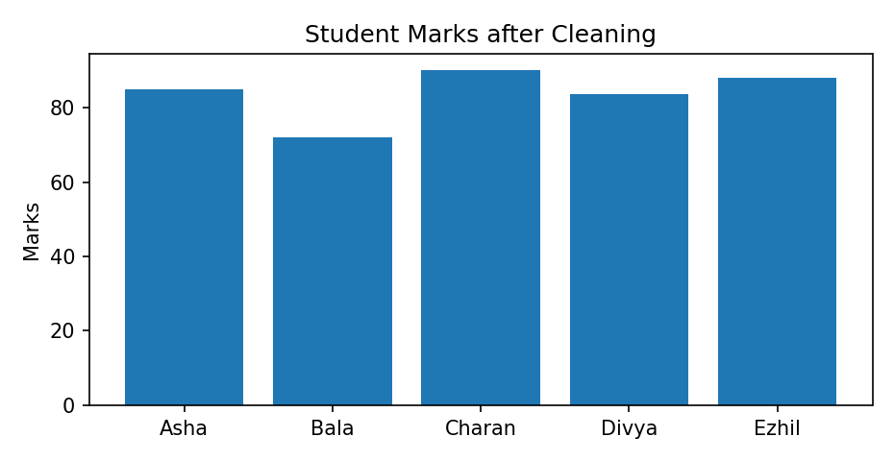

Result
CSV data was loaded, missing values were filled, summary statistics were generated and marks were visualized.

3.a — Data Visualization using Line Plot

Aim
To perform the experiment using Python and interpret the generated output.

Program / Input Code
import matplotlib.pyplot as plt

months = ["Jan", "Feb", "Mar", "Apr", "May", "Jun"]
sales = [20, 25, 22, 30, 35, 40]

plt.plot(months, sales, marker="o", linestyle="-", label="Sales")
plt.title("Monthly Sales")
plt.xlabel("Month"); plt.ylabel("Sales (units)")
plt.legend(); plt.grid(True); plt.tight_layout(); plt.show()
print("Highest sales:", max(sales), "units")

Expected Output
Highest sales: 40 units

Visualization
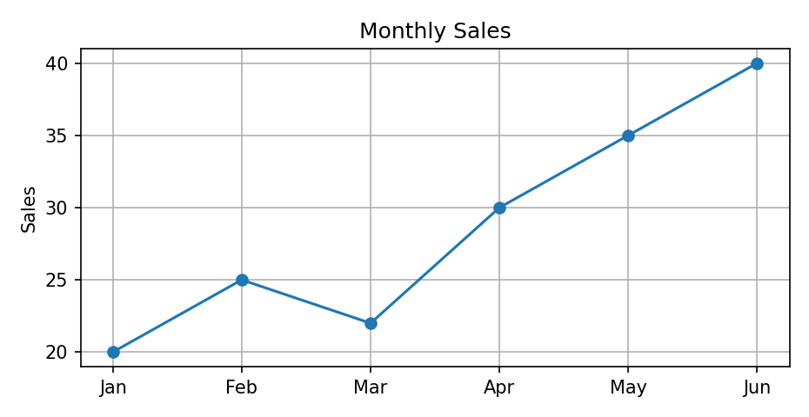

Result
Line plot displays the change in sales over time; sales reach a maximum of 40 units in June.

3.b — Data Visualization using Bar Chart

Aim
To perform the experiment using Python and interpret the generated output.

Program / Input Code
import matplotlib.pyplot as plt

subjects = ["Python", "DBMS", "Maths", "English"]
marks = [90, 85, 78, 88]

plt.bar(subjects, marks)
plt.title("Marks in Different Subjects")
plt.xlabel("Subject"); plt.ylabel("Marks")
plt.ylim(0, 100); plt.tight_layout(); plt.show()
print("Average mark:", sum(marks) / len(marks))

Expected Output
Average mark: 85.25

Visualization
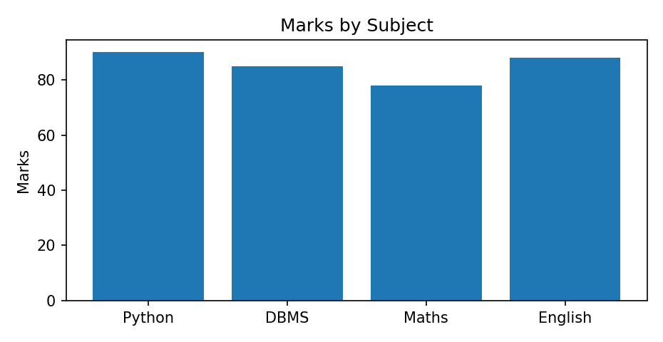

Result
Bar chart compares marks across subjects. Python has the highest mark (90).

3.c — Data Visualization using Pie Chart

Aim
To perform the experiment using Python and interpret the generated output.

Program / Input Code
import matplotlib.pyplot as plt

labels = ["Python", "Java", "SQL", "Statistics"]
values = [40, 25, 20, 15]

plt.pie(values, labels=labels, autopct="%1.1f%%", startangle=90)
plt.title("Skill Distribution")
plt.axis("equal"); plt.show()
print("Total percentage:", sum(values), "%")

Expected Output
Total percentage: 100 %

Visualization
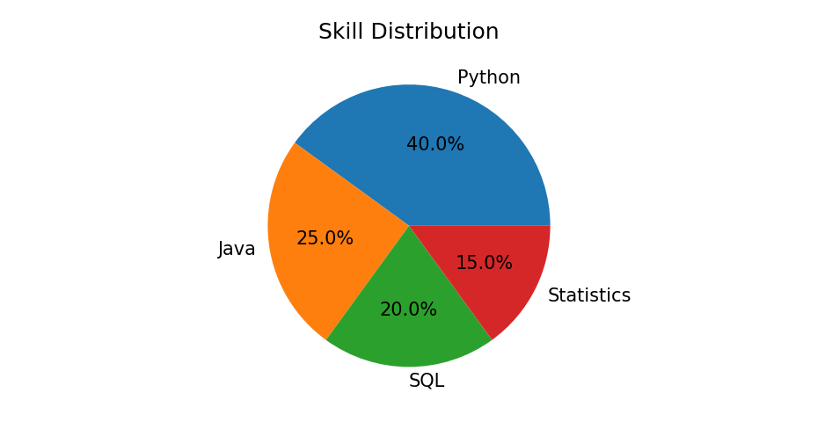

Result
Pie chart shows each skill's share; Python has the largest share at 40%.

4 — Count Word Frequency in a Body of Text

Aim
To perform the experiment using Python and interpret the generated output.

Program / Input Code
import re
from collections import Counter

text = "Data science is useful. Data science uses Python, and Python is powerful."
words = re.findall(r"\b[a-zA-Z]+\b", text.lower())
frequency = Counter(words)

print("Word frequencies:")
for word, count in frequency.most_common():
print(word, ":", count)

Expected Output
Word frequencies:
data : 2
science : 2
is : 2
python : 2
useful : 1
uses : 1
and : 1
powerful : 1

Result
Word frequency counting identifies how many times each word occurs in the given text.

5 — Data Collection and Initial Exploration

Aim
To perform the experiment using Python and interpret the generated output.

Program / Input Code
import pandas as pd

data = {
"Name": ["Asha", "Bala", "Charan", "Divya", "Ezhil"],
"Age": [20, 21, 19, 22, 20],
"Department": ["CSE", "IT", "CSE", "ECE", "IT"],
"Score": [85, 78, 92, 88, 80]
}
df = pd.DataFrame(data)

print("Dataset:\n", df)
print("\nShape:", df.shape)
print("\nColumns:", list(df.columns))
print("\nData types:\n", df.dtypes)
print("\nInformation:")
df.info()
print("\nStatistical summary:\n", df.describe(include="all"))
print("\nMissing values:\n", df.isnull().sum())

Expected Output
Shape: (5, 4)
Columns: ['Name', 'Age', 'Department', 'Score']
Missing values: 0 in every column
The describe() output gives count, mean, standard deviation, minimum and maximum for numeric columns.

Result
Sample data was collected into a DataFrame and its structure, data types, summary statistics and missing values were examined.

6 — Time Series Analysis of Website Traffic

Aim
To perform the experiment using Python and interpret the generated output.

Program / Input Code
import pandas as pd
import matplotlib.pyplot as plt

dates = pd.date_range("2024-01-01", periods=12, freq="MS")
visits = [120, 135, 128, 150, 170, 165, 190, 210, 205, 230, 250, 270]
df = pd.DataFrame({"Date": dates, "Visits": visits}).set_index("Date")

df["3_Month_Moving_Average"] = df["Visits"].rolling(3).mean()
print(df)
print("\nTotal visits:", df.Visits.sum())

df[["Visits", "3_Month_Moving_Average"]].plot(marker="o")
plt.title("Website Traffic and 3-Month Moving Average")
plt.xlabel("Month"); plt.ylabel("Visits")
plt.tight_layout(); plt.show()

Expected Output
Total visits: 2223
The moving average smooths short-term fluctuations and helps reveal the overall trend.

Visualization
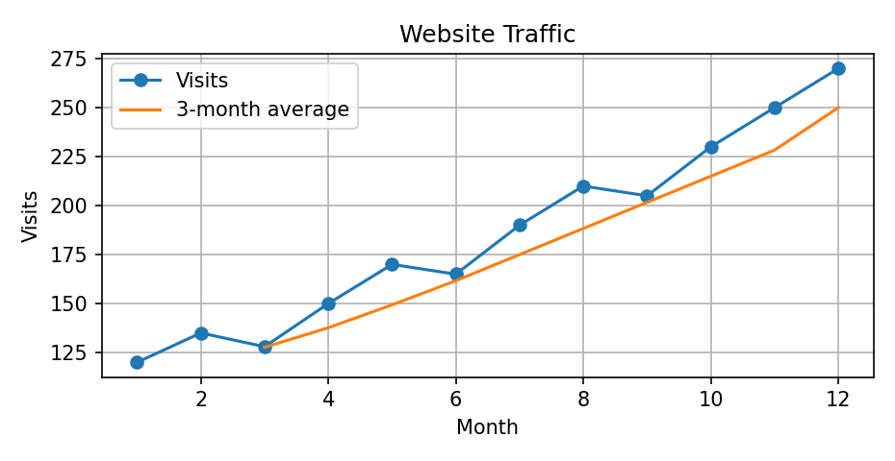

Result
Website visits generally increase over the year. The moving average makes the upward trend easier to observe.

7 — Random Sampling and Sampling Distribution

Aim
To perform the experiment using Python and interpret the generated output.

Program / Input Code
import numpy as np
import matplotlib.pyplot as plt

np.random.seed(42)
population = np.random.normal(loc=70, scale=10, size=10000)

sample_means = []
for _ in range(500):
sample = np.random.choice(population, size=30, replace=True)
sample_means.append(sample.mean())

print("Population mean:", round(population.mean(), 2))
print("Mean of sample means:", round(np.mean(sample_means), 2))
print("Standard error of sample means:", round(np.std(sample_means, ddof=1), 2))

plt.hist(sample_means, bins=25, edgecolor="black")
plt.title("Sampling Distribution of Sample Mean")
plt.xlabel("Sample mean"); plt.ylabel("Frequency")
plt.tight_layout(); plt.show()

Expected Output
Population mean: approximately 70
Mean of sample means: approximately 70
The histogram of sample means is approximately bell-shaped.

Visualization
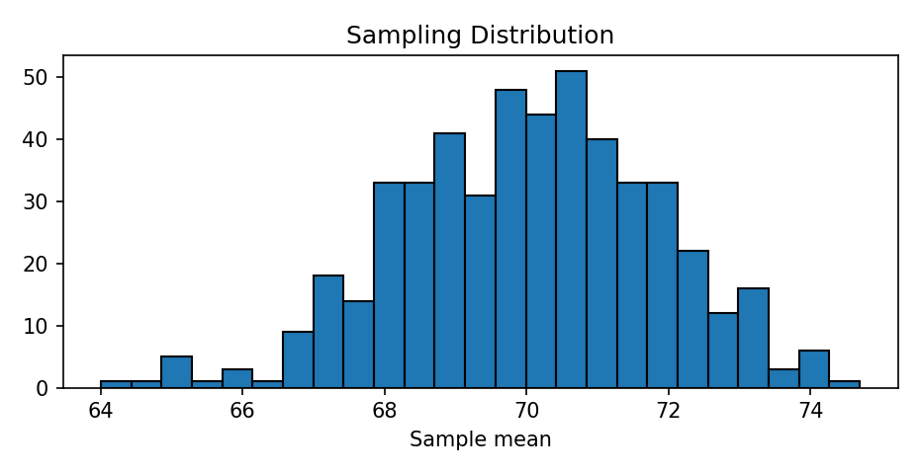

Result
Repeated random samples produce a sampling distribution centered near the population mean.

8 — Conduct Z-Test using Python

Aim
To perform the experiment using Python and interpret the generated output.

Program / Input Code
from statsmodels.stats.weightstats import ztest

# Example: test whether the sample mean differs from 50
sample = [52, 49, 51, 53, 48, 50, 54, 52, 51, 49,
53, 52, 50, 48, 51, 52, 54, 49, 50, 53]

z_stat, p_value = ztest(sample, value=50)
print("Sample mean:", sum(sample) / len(sample))
print("Z statistic:", round(z_stat, 4))
print("P-value:", round(p_value, 4))

alpha = 0.05
if p_value < alpha:
print("Reject H0: significant difference from 50.")
else:
print("Fail to reject H0: insufficient evidence of a difference.")

Expected Output
Sample mean: 51.05
Z statistic and p-value are calculated by statsmodels.
Decision is based on comparing p-value with 0.05.

Result
The Z-test compares the sample mean with the hypothesized population mean. A p-value below 0.05 indicates statistical significance. This example assumes a known/large-sample standard-error setting.

9 — Matplotlib Library and its Uses

Aim
To perform the experiment using Python and interpret the generated output.

Program / Input Code
import matplotlib.pyplot as plt

x = [1, 2, 3, 4, 5]
y = [2, 4, 6, 8, 10]

plt.figure(figsize=(9, 3))
plt.subplot(1, 3, 1)
plt.plot(x, y, marker="o"); plt.title("Line")
plt.subplot(1, 3, 2)
plt.bar(x, y); plt.title("Bar")
plt.subplot(1, 3, 3)
plt.scatter(x, y); plt.title("Scatter")
plt.tight_layout(); plt.show()
print("Matplotlib supports line, bar, scatter, histogram and many other plots.")

Expected Output
Matplotlib supports line, bar, scatter, histogram and many other plots.

Visualization
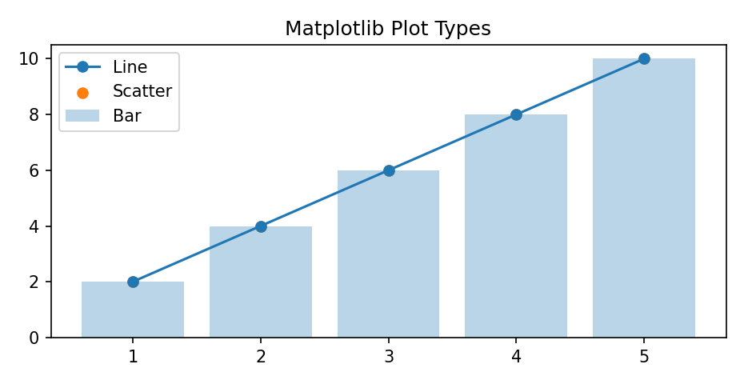

Result
Matplotlib was used to create line, bar and scatter plots for data visualization.

10 — Array Functions in Data Science (NumPy)

Aim
To perform the experiment using Python and interpret the generated output.

Program / Input Code
import numpy as np

a = np.array([10, 20, 30, 40, 50])
print("Array:", a)
print("Shape:", a.shape)
print("Mean:", np.mean(a))
print("Median:", np.median(a))
print("Sum:", np.sum(a))
print("Maximum:", np.max(a))
print("Minimum:", np.min(a))
print("Reshaped array:\n", a.reshape(5, 1))
print("Array + 5:", a + 5)

Expected Output
Array: [10 20 30 40 50]
Shape: (5,)
Mean: 30.0
Median: 30.0
Sum: 150
Maximum: 50
Minimum: 10
Reshaped array:
[[10]
[20]
[30]
[40]
[50]]
Array + 5: [15 25 35 45 55]

Result
NumPy array operations perform numerical calculations efficiently and support reshaping and vectorized arithmetic.

11 — Pandas Library in Data Science

Aim
To perform the experiment using Python and interpret the generated output.

Program / Input Code
import pandas as pd

df = pd.DataFrame({
"Name": ["Asha", "Bala", "Charan"],
"Age": [20, 21, 19],
"Marks": [85, 78, 92]
})
print("DataFrame:\n", df)
print("\nFirst two rows:\n", df.head(2))
print("\nMarks column:\n", df["Marks"])
print("\nAverage marks:", df["Marks"].mean())
print("\nSorted by marks:\n", df.sort_values("Marks", ascending=False))
print("\nShape:", df.shape)

Expected Output
Average marks: 85.0
Shape: (3, 3)
The DataFrame displays three student records with columns Name, Age and Marks.

Result
Pandas was used to create, select, summarize and sort tabular data.

12 — Detect Outliers in a Dataset using IQR

Aim
To perform the experiment using Python and interpret the generated output.

Program / Input Code
import pandas as pd
import matplotlib.pyplot as plt

data = pd.Series([10, 12, 12, 13, 12, 14, 15, 13, 12, 100])
Q1 = data.quantile(0.25)
Q3 = data.quantile(0.75)
IQR = Q3 - Q1
lower = Q1 - 1.5 * IQR
upper = Q3 + 1.5 * IQR
outliers = data[(data < lower) | (data > upper)]

print("Q1:", Q1, "Q3:", Q3, "IQR:", IQR)
print("Lower bound:", lower, "Upper bound:", upper)
print("Outliers:", outliers.tolist())

plt.boxplot(data, vert=False)
plt.title("Box Plot for Outlier Detection")
plt.xlabel("Value"); plt.show()

Expected Output
Q1, Q3 and IQR are calculated from the sample.
Outliers: [100]

Visualization
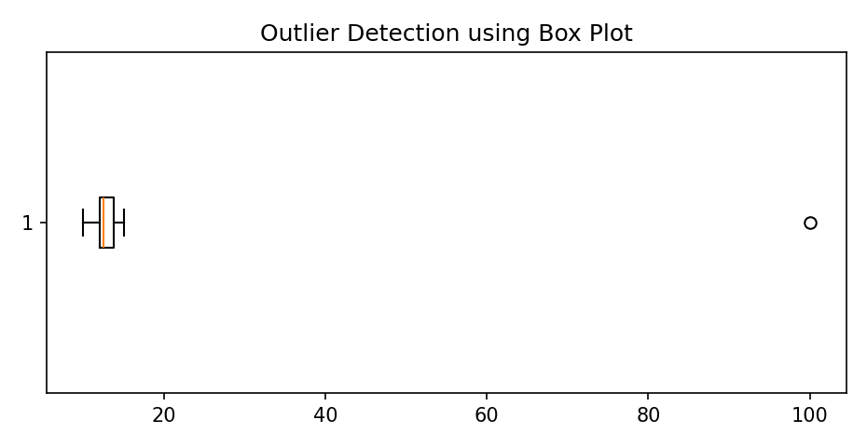

Result
The IQR method identifies 100 as an outlier in the sample dataset.

13 — Handle Missing Values and Inappropriate Data

Aim
To perform the experiment using Python and interpret the generated output.

Program / Input Code
import pandas as pd
import numpy as np

df = pd.DataFrame({
"Age": [20, 21, np.nan, 200, 22],
"Marks": [85, np.nan, 90, 75, 88],
"Name": ["Asha", "Bala", "Charan", "Divya", "Ezhil"]
})
print("Before cleaning:\n", df)
df["Age"] = df["Age"].fillna(df["Age"].median())
df["Marks"] = df["Marks"].fillna(df["Marks"].mean())
# Treat impossible age 200 as missing, then impute
df.loc[df["Age"] > 100, "Age"] = np.nan
df["Age"] = df["Age"].fillna(df["Age"].median())
print("\nAfter cleaning:\n", df)
print("\nMissing values:\n", df.isnull().sum())

Expected Output
Before cleaning: dataset contains missing values and an invalid age of 200.
After cleaning: missing values are imputed and invalid age is replaced.
Missing values: 0 in all columns.

Result
Missing and inappropriate values were detected and handled, producing a clean dataset.

14 — Feature Scaling

Aim
To perform the experiment using Python and interpret the generated output.

Program / Input Code
import pandas as pd
from sklearn.preprocessing import MinMaxScaler, StandardScaler

df = pd.DataFrame({"Age": [20, 30, 40, 50],
"Salary": [20000, 40000, 60000, 80000]})
print("Original data:\n", df)

minmax = MinMaxScaler()
standard = StandardScaler()
print("\nMin-Max scaled:\n",
pd.DataFrame(minmax.fit_transform(df), columns=df.columns).round(2))
print("\nStandard scaled:\n",
pd.DataFrame(standard.fit_transform(df), columns=df.columns).round(2))

Expected Output
Min-Max scaled:
Age Salary
0 0.00 0.00
1 0.33 0.33
2 0.67 0.67
3 1.00 1.00

Standard scaled values are centered around 0 with unit variance.

Result
Min-Max scaling transforms features to the 0–1 range, while standardization transforms them to approximately zero mean and unit variance.

15 — Data Preprocessing in Data Science

Aim
To perform the experiment using Python and interpret the generated output.

Program / Input Code
import pandas as pd
from sklearn.preprocessing import LabelEncoder, MinMaxScaler

df = pd.DataFrame({
"Age": [20, 25, None, 30],
"City": ["Chennai", "Madurai", "Chennai", "Trichy"],
"Income": [20000, 30000, 25000, 40000]
})
print("Raw data:\n", df)

df["Age"] = df["Age"].fillna(df["Age"].median())
encoder = LabelEncoder()
df["City_Code"] = encoder.fit_transform(df["City"])
scaler = MinMaxScaler()
df[["Age_Scaled", "Income_Scaled"]] = scaler.fit_transform(df[["Age", "Income"]])
print("\nPreprocessed data:\n", df)

Expected Output
Raw data contains one missing Age value and a categorical City column.
Preprocessed data contains imputed age, encoded city and scaled numeric features.

Result
Data preprocessing handled missing values, encoded categorical data and scaled numerical features.

16 — EDA: Quantitative and Qualitative Analysis

Aim
To perform the experiment using Python and interpret the generated output.

Program / Input Code
import pandas as pd
import matplotlib.pyplot as plt

df = pd.DataFrame({
"Department": ["CSE", "IT", "CSE", "ECE", "IT", "CSE"],
"Score": [85, 78, 92, 75, 88, 90],
"Age": [20, 21, 19, 20, 22, 21]
})
print("QUANTITATIVE ANALYSIS")
print(df[["Score", "Age"]].describe())
print("\nQUALITATIVE ANALYSIS")
print(df["Department"].value_counts())

fig, axes = plt.subplots(1, 2, figsize=(8, 3))
df["Score"].hist(ax=axes[0], bins=5)
axes[0].set_title("Score Distribution")
df["Department"].value_counts().plot(kind="bar", ax=axes[1])
axes[1].set_title("Department Frequency")
plt.tight_layout(); plt.show()

Expected Output
Quantitative analysis: describe() reports count, mean, standard deviation, min, quartiles and max.
Qualitative analysis: value_counts() reports the frequency of each department.

Visualization
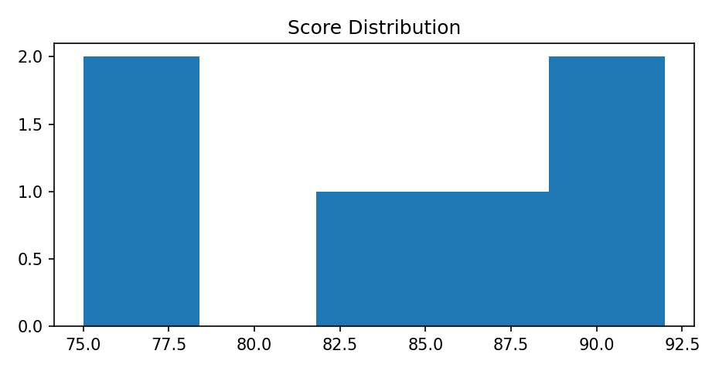

Result
Quantitative variables were summarized statistically and qualitative categories were examined using frequency counts.

17 — Linear Regression

Aim
To perform the experiment using Python and interpret the generated output.

Program / Input Code
import numpy as np
import matplotlib.pyplot as plt
from sklearn.linear_model import LinearRegression
from sklearn.metrics import mean_squared_error, r2_score

# Hours studied and exam marks
X = np.array([1, 2, 3, 4, 5, 6]).reshape(-1, 1)
y = np.array([35, 40, 50, 55, 65, 70])

model = LinearRegression()
model.fit(X, y)
pred = model.predict(X)
print("Slope:", round(model.coef_[0], 2))
print("Intercept:", round(model.intercept_, 2))
print("R2 score:", round(r2_score(y, pred), 3))
print("Predicted mark for 7 hours:", round(model.predict([[7]])[0], 2))

plt.scatter(X, y, label="Actual")
plt.plot(X, pred, label="Regression line")
plt.xlabel("Hours studied"); plt.ylabel("Marks")
plt.title("Linear Regression"); plt.legend(); plt.show()

Expected Output
The model learns a positive relationship between study hours and marks.
Predicted mark for 7 hours: approximately 80 (depends on fitted line).

Visualization
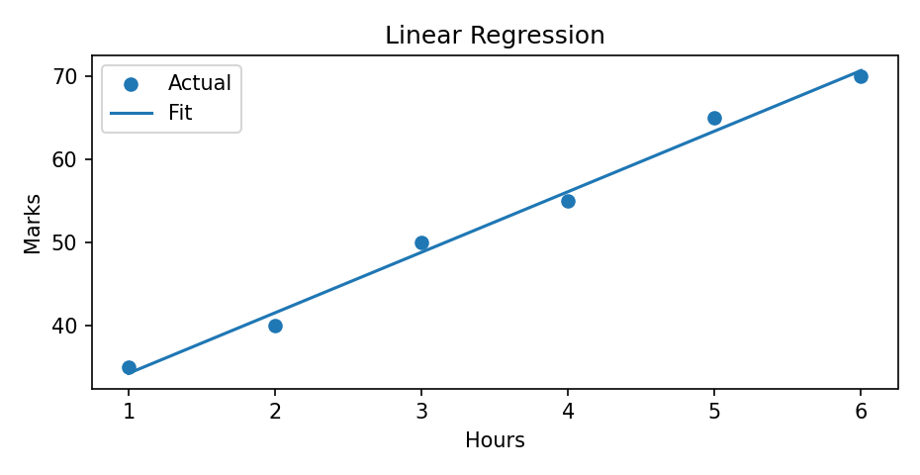

Result
Linear regression fits a straight line to predict a continuous target variable (marks) from study hours.

18 — K-Nearest Neighbors (KNN) Algorithm

Aim
To perform the experiment using Python and interpret the generated output.

Program / Input Code
from sklearn.datasets import load_iris
from sklearn.model_selection import train_test_split
from sklearn.preprocessing import StandardScaler
from sklearn.neighbors import KNeighborsClassifier
from sklearn.metrics import accuracy_score, classification_report

iris = load_iris()
X_train, X_test, y_train, y_test = train_test_split(
iris.data, iris.target, test_size=0.2, random_state=42, stratify=iris.target)

scaler = StandardScaler()
X_train = scaler.fit_transform(X_train)
X_test = scaler.transform(X_test)

model = KNeighborsClassifier(n_neighbors=5)
model.fit(X_train, y_train)
pred = model.predict(X_test)
print("Accuracy:", round(accuracy_score(y_test, pred), 3))
print("\nClassification report:\n",
classification_report(y_test, pred, target_names=iris.target_names))

Expected Output
Accuracy: typically around 0.93–1.00 for this split.
Classification report displays precision, recall, f1-score and support for each Iris class.

Result
KNN classifies a new sample using the majority class among its five nearest training samples.

19 — Logistic Regression

Aim
To perform the experiment using Python and interpret the generated output.

Program / Input Code
from sklearn.datasets import load_breast_cancer
from sklearn.model_selection import train_test_split
from sklearn.preprocessing import StandardScaler
from sklearn.linear_model import LogisticRegression
from sklearn.metrics import accuracy_score, confusion_matrix, classification_report
import matplotlib.pyplot as plt

data = load_breast_cancer()
X_train, X_test, y_train, y_test = train_test_split(
data.data, data.target, test_size=0.2, random_state=42, stratify=data.target)
scaler = StandardScaler()
X_train = scaler.fit_transform(X_train)
X_test = scaler.transform(X_test)

model = LogisticRegression(max_iter=5000)
model.fit(X_train, y_train)
pred = model.predict(X_test)
print("Accuracy:", round(accuracy_score(y_test, pred), 3))
print("Confusion matrix:\n", confusion_matrix(y_test, pred))
print("\n", classification_report(y_test, pred, target_names=data.target_names))

Expected Output
Accuracy: commonly around 0.96–0.99 for this dataset and split.
Confusion matrix and classification report show the classification performance.

Result
Logistic regression predicts a categorical class using probabilities. The model is evaluated using accuracy, confusion matrix, precision and recall.

20 — K-Means Clustering

Aim
To perform the experiment using Python and interpret the generated output.

Program / Input Code
import matplotlib.pyplot as plt
from sklearn.datasets import make_blobs
from sklearn.cluster import KMeans

X, y_true = make_blobs(n_samples=150, centers=3, cluster_std=0.8, random_state=42)
model = KMeans(n_clusters=3, random_state=42, n_init=10)
labels = model.fit_predict(X)

print("Cluster centers:\n", model.cluster_centers_.round(2))
print("Inertia:", round(model.inertia_, 2))

plt.scatter(X[:, 0], X[:, 1], c=labels)
plt.scatter(model.cluster_centers_[:, 0], model.cluster_centers_[:, 1],
marker="X", s=200, label="Centroids")
plt.title("K-Means Clustering (k=3)")
plt.xlabel("Feature 1"); plt.ylabel("Feature 2")
plt.legend(); plt.show()

Expected Output
The algorithm groups the 150 data points into 3 clusters.
Cluster centers and inertia are printed by the program.

Visualization
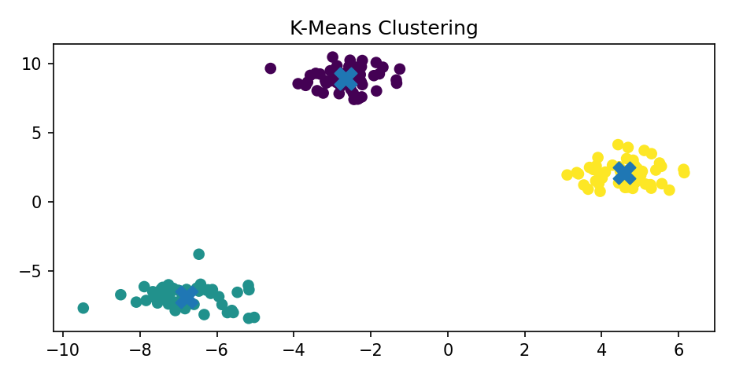

Result
K-Means successfully groups similar data points into three clusters and identifies their centroids.

